Automatic License Plate Recognition

ACKNOWLEDGEMENTS

The successful completion of this project has been possible with many people in and around our work and the institution and hence without a heartfelt acknowledgement to one and all, this project cannot be considered successful.

We sincerely thank Arpit Agarwal for her guidance, encouragement and support throughout the project. We also thank them her taking care of each and every aspect of the project timely and helping us to complete the project in time.

We also thank Dr. G. L. Prajapati for his valuable comments and guidance.

We also thank Dr. Sanjeev Tokekar for his guidance.

Also we thank Mr. Arpit Agrawal for his guidance.

Lastly we thank our families and friends for the encouragement and support they provided for the successful completion of the project.
ABSTRACT

In Traffic surveillance, tracking of the number plate from the vehicle is an important task, which demands intelligent solution. In this document, extraction and recognition of number plate from vehicles image has been done using MATLAB. It is assumed that images of the vehicle have been captured from Digital Camera.
Automatic License Plate Recognition System is developed using Histogram graph algorithm in MATLAB. It involves capturing image from camera and converting it into gray scale image for preprocessing. Noise removal through median filter is done on the gray scaled image, after which horizontal and vertical edge processing is done and corresponding histograms are obtained. Probable regions are extracted by applying dynamic threshold on histogram values after which most probable region is selected using the property that plate characters and plate background differ highly in pixel intensities.
For detection each character separately from detected license plate Template Matching algorithm is used and alphanumeric characters on plate are extracted and recognized by comparing them to template images of alphanumeric characters.
This report presents a technique developed in MATLAB which could be used for vehicle license plate recognition. Recognized number plate can be seen in a text file for verification purpose. Number plate identification is helpful in finding stolen cars, car parking management system and identification of vehicle in traffic.

TABLE OF CONTENTS
Recommendation……………………………………………………………………..i
Dissertation Approval Sheet………………………………………………………....ii
Candidate Declaration……………………………………………….……………....iii
Acknowledgements……………………………………………………….…………iv
Abstract……………………………………………………………………………....v
Table of Contents…………………………………………………………………....vi

Chapter-1 Introduction
1.1 Overview and issues involved……………………………………………….....1
1.2 Problem definition……………………………………………………………...2
1.3 Proposed solution……………………………………………………………....3

Chapter-2 Literature Survey
  - Edge Based Approaches…………………………………………………….…4
  - Color Based Approaches……………………………………………………....4
  - Texture Based Approaches…………………………………………………….5
  - Character Based Approaches…………………………………………………..5
  - Methodology Used……………………………………………………………..6

Chapter-3 Analysis
3.1 Software Requirements………………………………………………………….8
3.2 Hardware Requirements………………………………………………………..10

Chapter-4 Methodologies and Algorithms
4.1 License Plate Detection…………………………………………………………11
4.2 License Plate Recognition………………………………………………………18
Chapter-5 Conclusion……………………………………………………………..22
REFERENCES……………………………………………………………………….23

Chapter-1 Introduction

1.1 Overview and issues involved
The purpose is to develop an Automatic License Plate Recognition System that can effectively aid Intelligent Transportation Initiative (ITS) in vehicle identification using vehicle license plate.

In the last couple of decades, the number of vehicles has been increasing day by day. With this increase, it is becoming difficult to keep track of each vehicle for the law of enforcement and traffic management. Manual recognition of vehicles is quiet inefficient, slow and highly prone to errors. Therefore the need of Automatic License Plate Detection and recognition system has increased manifolds.

An integrated license plate detection and recognition system has numerous applications under the ITS initiative. The prominent among them are:
- Automatic ticket generation for offenders of traffic rules: A database can be maintained which would store driver identification information. Database can be used for emailing the driver about the traffic offence committed and also in retrieval of fine charged for the offence.
- Victim identification at an accident scene: License plates can help in identification the driver of vehicle. This information can be utilized for fast communication about accident to the people concerned with the person involved in accident.
- Identification of stolen vehicles: Stolen vehicles can be marked differently in vehicle database and during police patrolling vehicle identification through ALPR system would tell which vehicle is stolen.
- Automatic toll collection: Similar to automatic ticket generation; database can be maintained and can be linked to some e-wallet through which fast and efficient toll collection can be done. It would eliminate the need to wait for a considerable time at toll booths and also reduce queuing delays on highways.
- Analysis of city traffic during peak periods: Increasing number of vehicles on roads increases the chances of congestion along routes. Using the ALPR systems, count of the number of vehicles on a particular road can be determined which in turn could used to provide congestion information to a user searching for fast routes between landmarks on some online city map (such as using Google Maps). This would result in fast movement of traffic as well as uniform distribution of vehicles along multiple routes.
- Parking management systems: Parking lots can use ALPR systems in fast identification of vehicles. Currently, most of the parking lots in India use manual systems for storing vehicle information. Administrators need to be present at the parking lot to note down the vehicle number plate and store in some database. Parking charges are also collected manually. This task consumes considerable time, requires manpower and prone to inaccurate recordings. ALPR systems can make the process efficient by recognizing and automatically storing the user data in the database. This database when linked to some e-wallet can be used for automatic collecting of parking charges.
Here the system developed will be prominently useful in parking management systems and for automatic toll collection. This is mainly because under these applications the vehicle image obtained is least blurry and number of vehicles per image is controlled. These requirements are essential for the ALPR system developed in this project.
  - Problem Domain
There is a need to identify all the vehicles entering and exiting a parking lot. The current system involves a person to manually maintain a register or database related to visitors coming in. This process is tedious, time consuming and is also prone to inaccurate recordings. Similarly, toll booths on highways require administrators to present and manually check each vehicle passing through the toll booth.

A simple ALPR system can be developed in which a digital camera captures image of vehicle license plate from appropriate distance and feeds it to the software system for number plate recognition. After capturing the image, following are the major problems encountered by ALPR software in identification of number plate characters:
- License Plate Localization: Image captured contains a lot of things other than the actual license plate. ALPR system needs to extract the exact license plate for further processing.
- Character Segmentation: From the localized license plate, all the characters need to be properly separated and extracted for the purpose of identification. System must also ensure that characters are differentiated from any other characters that might be present on license plate or elsewhere in image.

  - Solution Domain
The proposed solutions to the challenges in the ALPR system are as follows:
- License Plate Localization: License plate is localized from the image using the property that plate characters are very dark in color compared to the plate background. Also the plate background is uniformly colored and is usually of very light color shade (such as white or yellow). Pixel intensities can thus be compared and a region with highest variation in color is selected as most probable region for license plate.
- Character Segmentation: The localized plate can be resized to increase the pixel distance between plate characters. Morphological processing followed by bounding box formation and character cropping are applied so that each character is extracted separately and accurately.

Chapter-2 Literature Survey

License plate detection aims to localize the license plates in the image in the form of bounding boxes. The challenge in this task is to detect license plates accurately, efficiently and in real-time. Previous work on license plate detection classifies existing algorithms into roughly four categories:

  - Edge Based Approaches
These approaches try to find regions in the image with higher edge density, since license plates have higher edge density than elsewhere in the image and are normally in a rectangular shape with a specific aspect ratio.
Considering the property that the brightness change in license plate region is more remarkable and more frequent than elsewhere, some methods use edge detector combined with some morphological operations to find the rectangles which are regarded as candidate license plate [3, 4]. Characteristic features such as license plate aspect ratio, distance between objects, character height and spacing, etc are some defining structural elements for morphological operations.
Certain methods use Prewitt arithmetic operator [5]. The exact location of plate is then determined by horizontal and vertical projections. Hough transform is also used sometimes to find the strong vertical and horizontal lines as the bounds of the license plate [6].
Edge-based methods are fast in detection speed. However, the drawback of these approaches is that they cannot be applied to complex images as they are too sensitive to unwanted edges. Also, it is difficult to find license plates if they are blurry.

  - Color Based Approaches
These approaches are based on the observation that color of the license plate is usually different from that of the car body.
HSI color model is used in [7] to detect candidate license plate regions, which are later verified by position histogram. In [8], first the image is segmented into different regions according to different colours via mean-shift algorithm. License plates are then distinguished based on features including rectangularity, aspect ratio and edge density. In [9], a method to detect license plates in RGB images based on the different foreground and background colors is proposed. They developed a color edge detector which is sensitive to black-white, red-white and green-white edges.
Color-based methods can be used to detect inclined or deformed license plates. However, they cannot distinguish other objects in the image with similar color and size as the license plates and they are very sensitive to various illumination changes in natural scene images.

2.3 Texture Based Approaches
These approaches try to detect license plates according to the unconventional pixel intensity distribution in plate regions.
In [10], a license plate detection method is proposed that uses both global statistical features and local Haar-like features. Classifiers based on global features exclude more than 70% of background area, while classifiers based on local Haar-like features are robust to brightness, color, size and position of license plates.
In [11], wavelet transform is applied at first to get the horizontal and vertical details of an image. Empirical mode decomposition (EMD) analysis is then employed to deal with the projection data and locate the desired wave crest which indicates the position of a license plate.
Texture-based methods use more discriminative characteristics than edge or color, but result in a higher computational complexity.

2.4 Character Based Approaches
These approaches regard the license plate as a string of characters and detect it via examining the presence of characters in the image.
In [12], it is proposed to detect license plate based on image saliency. This method firstly segments out characters in the image with a high recall using an intensity saliency map. Then applies a sliding window on these characters to compute some saliency related features and detect license plates.
In [13], Maximally Stable Extremal Region (MSER) is applied at the first stage to extract candidate characters in images. Conditional random field (CRF) is then constructed to represent the relationship among license plate characters. License plates are finally localized through the belief propagation inference on CRF.
Character-based methods are more reliable and can lead to a high recall. However, the performance is affected largely by the general text in the image background.
2.5 Methodology Used:
We propose the following method for this project. License Plate detection is based on Edge based approaches. For Plate Recognition we use Template Matching approach.

IMAGE CAPTURING
CONVERT TO GRAYSCALE
HORIZONTAL AND VERTICAL EDGE PROCESSING
PASSING THROUGH LOW PASS FILTER
SEGMENTATION OF PROBABLE ROIs
SELECTION OF MOST PROBABLE ROI
RESIZING THE IMAGE
CONVOLUTION & BINARIZATION OF IMAGE
CHARACTER SEGMENTATION
CHARACTER RECOGNITION THROUGH TEMPLATE MATCHING
Fig. 2.1: Methodology Use
Chapter 3 Analysis
3.1 Software Requirements
MATLAB is a programming language developed by MathWorks. It started out as a matrix programming language where linear algebra programming was simple. It can be run both under interactive sessions and as a batch job. 64 Bit, MATLAB, Simulink and PolySpace Product families is required to develop the system.
Operating System:
MATLAB software can run on various operating systems such as Ubuntu 17.10, Ubuntu 16.04 LTS, Ubuntu 14.04 LTS, Debian 9, Debian 8, Windows 8.1, Windows 10, etc.
Processors: Minimum any Intel or AMD x86-64 processor.
RAM: Minimum 4GB is required.
Image Processing ToolBox:
Image Processing Toolbox provides a comprehensive set of reference-standard algorithms and workflow apps for image processing, analysis, visualization, and algorithm development. You can perform image segmentation, image enhancement, noise reduction, geometric transformations, image registration, and 3D image processing.
Functions used in Image Processing:
- imresize (I , [row col]): Resizes the image into specified dimension.
- strel ('disk' , r, n ): A strel object represents a flat morphological structuring element, which is an essential part of morphological dilation and erosion operations. A flat structuring element is a binary valued neighborhood, either 2-D or multidimensional, in which the true pixels are included in the morphological computation, and the false pixels are not. The center pixel of the structuring element, called the origin, identifies the pixel in the image being processed. Use the strel function to create a flat structuring element. You can use flat structuring elements with both binary and grayscale images.
- J = imdilate ( I , se ): Dilates the grayscale, binary, or packed binary image I, returning the dilated image, J. se is a structuring element object or array of structuring element objects, returned by the strel or offsetstrel functions.
- J = imerode ( I , se ): Erodes the grayscale, binary, or packed binary image I, returning the eroded image, J. SE is a structuring element object or array of structuring element objects, returned by the strel.
- I = mat2gray (A, [amin amax]): Converts the matrix A to an intensity image I that contains values in the range 0 (black) to 1 (white). amin and amax are the values inA that correspond to 0 and 1 in I. Values less than amin become 0, and values greater than amax become 1.
- C = conv2 (A, B): Returns the two-dimensional convolution of matrices A and B. In applications such as image processing, it can be useful to compare the input of a convolution directly to the output. The conv2function allows you to control the size of the output.
- J = imadjust (I, [low_in high_in], [low_out high_out],gamma): Maps intensity values in I to new values in J, where gamma specifies the shape of the curve describing the relationship between the values in I and J.
- BW2 = bwmorph (BW, operation, n): Applies the operation n times. n can be Inf, in which case the operation is repeated until the image no longer changes.
- BW2 = bwareaopen(BW,P): Removes all connected components (objects) that have fewer than P pixels from the binary image BW, producing another binary image, BW2. The default connectivity is 8 for two dimensions, 26 for three dimensions, and conndef(ndims(BW), 'maximal') for higher dimensions. This operation is known as an area opening.

  - Hardware Requirements:
Hardware Components for Successful License Plate Recognition:
- Camera with a fast shutter speed to reduce motion blur - A high speed vehicles may require a cameras with a faster shutter speed to compensate for a vehicle's velocity.
Camera shutter speeds of 1/1000 sec may be necessary.

- Eclipse camera - Deployed to reduce the headlight glare and reflected light from a vehicle.
An eclipse camera is able refract the light toward the vehicle hence it can be used to produce a clear image.

- Infrared Night Vision Cameras - During areas of low light or in areas of total darkness, infrared cameras are used.

- Infrared illuminator - In certain conditions, an infrared camera will require additional infrared illumination because the standard led's on a night vision camera may only work for 15 to 30 ft.

Chapter 4 Methodologies and Algorithms

  - License Plate Detection:
The following steps are involved in license plate detection:
4.1.1 Image Capturing:
First step is to capture an image that is taken from a fixed angle and is parallel to the ground and taken for a vehicle which is stationary. Since the system uses color based approach, it must be ensured that image is under proper illumination. The captured image should be of sufficient resolution such as 450xNaN or above, else problem occurs during segmentation of Region of Interest (ROI) because of blurring of plate edges.
The captured is read into the system using MATLAB.
MATLAB Function used: imread( ‘image address’ ).
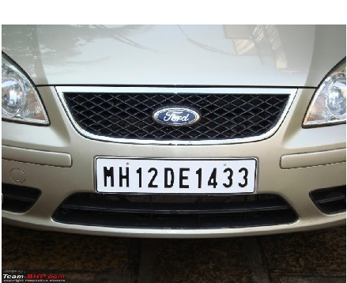

Fig. 4.1: Input Image

    - RGB to Gray-Scale:
The captured image is an RGB image and it must be converted into grayscale image. This is a necessary step because:
- In a grayscale image, information required from image is independent of color and generally relies on gray-level of the image.
- Secondly, one system is used for different images with different brightness and shades, so there intensities become same when they are converted into grayscale.
- Also, a RGB image is a 3-dimensional matrix and it takes thrice more memory than a grayscale image. The conversion helps speed up the detection process.
MATLAB Function used: rgb2gray(A). Here A is the input image.
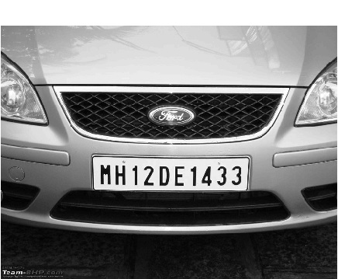

Fig. 4.2: Grayscale image

    - Noise Removal and Image Resizing:
In the next step noise removal from grayscale image is done to reduce noise in image. Median filtering is a nonlinear operation often used in image processing to reduce "salt and pepper" noise. Median filtering is more effective than convolution when the goal is to simultaneously reduce noise and preserve edges.
MATLAB Function used: medfilt2 ( A, B ). Here A is the image and B is the median filter used.
Also, for fast and efficient processing, we bring each image to a partially fixed resolution. This is done by resizing to NaNx450 resolution. Here NaN signifies that image height will adjust according to a fixed image width of 450 pixels.
MATLAB Function used: imresize( A, [m n]). Here m and n are the new dimensions of image.
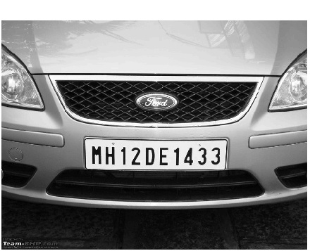

Fig. 4.3: Resized image

    - Horizontal and Vertical Edge processing:
Histogram is a graph representing the values of a variable quantity over a given range. Here we are using horizontal and vertical histogram which represents the column-wise and row-wise histogram respectively. To find a horizontal histogram, the algorithm traverses through each column of an image. In each column, the algorithm starts with the second pixel from the top.
The difference between second and first pixel is calculated. If the difference exceeds certain threshold, it is added to total sum of differences. Then, algorithm will move downwards to calculate the difference between the third and second pixels. So on, it moves until the end of a column and calculate the total sum of differences between neighboring pixels.
At the end, an array containing the column-wise sum is created. The same process is carried out to find the vertical histogram. In this case, rows are processed instead of columns.
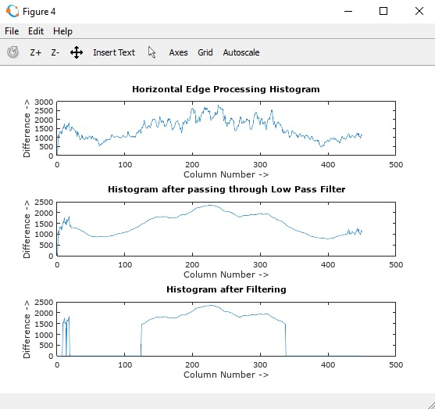

Fig. 4.4: Horizontal Histogram

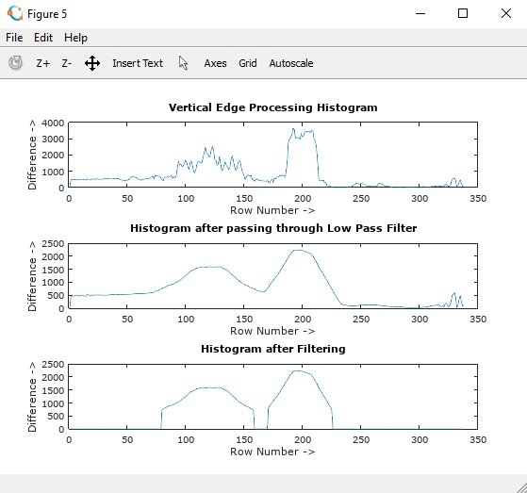

Fig. 4.5: Vertical Histogram

    - Low Pass Filter:
There are major changes between consecutive rows and columns Therefore, to prevent loss of important information in upcoming steps, it is advisable to smooth out such drastic changes in values of histogram. For the same, the histogram is passed through a low-pass digital filter. While performing this step, each histogram value is averaged out considering the values on it right-hand side and left-hand side. This step is performed on both the horizontal histogram as well as the vertical histogram.

Fig. 4.6: Vertical Histogram after low pass filtering

Fig. 4.7: Vertical Histogram after low pass filtering

    - Filter unwanted region:
Once the histograms are passed through a low-pass filter, a filter is applied to remove unwanted areas from an image. In this case, the unwanted areas are the rows and columns with low histogram values. A low histogram value indicates that the part of image contains very little variations among neighboring pixels. Since a region with a license plate contains a plain background with alphanumeric characters in it, the difference in the neighboring pixels, especially at the edges of characters and number plate, will be very high. This results in a high histogram value for such part of an image.

Fig. 4.8: Horizontal Histogram after filtering

Fig. 4.9: Horizontal Histogram after filtering

    - Segmentation of Image:
The next step is to find all the regions in an image that has high probability of containing a license plate. Co-ordinates of all such probable regions are stored in an array. In this step all the regions which have probability of license plate has been identified and coordinates of such probable region has been stored.

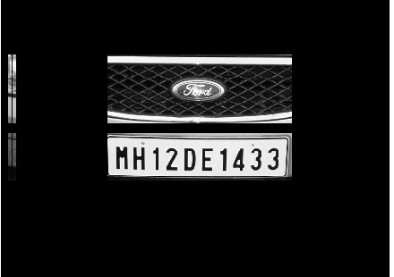

Fig. 4.10: Segmented Image

4.1.8 Final Extraction:
The output of segmentation process is all the regions that have maximum probability of containing a license plate. Out of these regions, the one with the maximum histogram value is considered as the most probable candidate for number plate. All the regions are processed row-wise and column-wise to find a common region having maximum horizontal and vertical histogram value. This is the region having highest probability of containing a license plate.

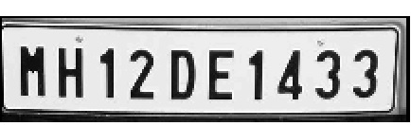

Fig. 4.11: Extracted License Plate

  - License Plate Recognition:
The following steps are involved in license plate recognition:

4.2.1 Resizing the License Plate Image:
The plate image obtained through detection process is resized into a higher resolution (100xNaN). This is done in order to ensure a larger pixel distance between the plate characters.
Greater pixel distance ensures that during image convolution and binarization, the plate characters do not get mixed up.

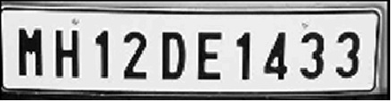

Fig. 4.12: Resized License Plate

    - Convolution and Binarization of License Plate:
The resized image is convoluted in order to obtain edge information of plate characters. Image binarization is done so as to assist template matching (character templates are stored as binary images)
Before convolution, the image is first dilated and then eroded. The difference of dilated and eroded image is taken as an input to convolution function. This process of dilation followed by erosion ensures that edge information about characters is retained.
Convolution is performed using a simple Box Blur filter. The Box Blur (also known as a box linear filter) is a spatial domain linear filter in which each pixel in the resulting image has a value equal to the average value of its neighboring pixels in the input image. It is a form of low-pass ("blurring") filter.

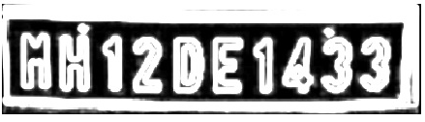

Fig. 4.13: Convoluted image

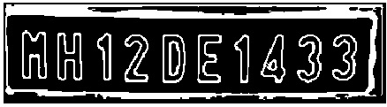

Fig. 4.14: Binarized image

    - Segmentation of License Plate Characters:
Character segmentation acts as a conduit between the license plate detection and character recognition. Here the characters are segmented from the extracted license plate so that all the characters are individually extracted for template matching. A license plate has high intensity variation regions and this is the basis for segmentation part.
Firstly, Bounding Boxes are formed around all the objects in the binarized license plate image.
Bounding Boxes around plate characters are recognized using an upper bound and a lower bound on the size of plate characters. Cropping of these character bounding boxes is then done.
Certain morphological operations such as filling, thinning, bridging, etc are then applied on individual plate characters. This is done so that the segmented characters resemble to character templates that are already stored. This improves efficiency of template matching.
Below are the images of individual characters obtained by above processing. These would be individually passed through template matching algorithm for character recognition.

Fig. 4.15: Segmented Characters

    - Recognition through template matching:
Template Matching is a technique that compares portions of images against one another. Sample of image may be used to recognize similar objects in the source image. If a standard deviation of the template image in comparison to source image is small enough, template matching may be used.
The matching process moves the template image to all possible positions in a larger source image and computes a numerical index that indicates how well the template matches the image in that position. Matching is done on a pixel by pixel basis. Template matching method is mainly used for classifying objects. Templates are most often used to identify printed characters, numbers and small other objects. In template matching method templates are correlated with the source image.
Correlation is a measure of degree to which two variables agree. The variables are the corresponding pixel values in two images, template and source. The correlation value is between -1 and +1. Higher the correlation value means strong relationship between the template and source image.

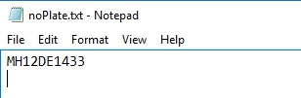

Fig. 4.16: Character recognition through Template Matching

Chapter 5 Conclusion

Automatic License plate recognition is the most interesting and challenging research topic from past few years. It is shown that the number plates are in different shapes and sizes, and have different colors in different countries. In India the most common vehicle license plate used are white or yellow as a background, and black used as foreground color. In this report, a system is proposed to localize license plate mainly for the vehicles in India and segmented the numbers as to identify each number separately. The system works satisfactorily when images are captured from fixed distance and captured from the centre position. Vehicle should be stationary and image is captured from fixed angle parallel to horizon.

Future Work:
This system is useful in parking lots and toll collection booths. Its applications can be extended if we used machine learning techniques for plate detection and plate recognition. By using convolutional neural networks (CNNs), efficiency of system can be improved as well as restrictions on capturing the input image can be reduced. CNNs can be trained to learn the features of plate license plate in an image and thus they can detect a license plate more accurately. Another CNN can be trained to recognize plate characters after the plate has been localized correctly.

REFERENCES

- Xin Li, “Vehicle License Plate Detection and Recognition”, University of Missouri--Columbia, 2010.
- J. Barroso, A. Rafael, E.L. Dagless “Number plate reading using computer vision”. In: IEEE Intern. Symposium on Industrial Electronics, ISIE 1997 (1997).
- D. Zheng, Y. Zhao, and J. Wang, “An efficient method of license plate location," Pattern Recogn. Lett., vol. 26, no. 15, pp. 2431-2438, 2005.
- M. A. Lalimia, S. Ghofrania, and D. McLernonb, “A vehicle license plate detection method using region and edge based methods," Comp & Electr. Engin., vol. 39, p. 834845, 2013.
- R. Chen and Y. Luo, “An improved license plate location method based on edge detection," in Proc. Int. Conf. Appl. Phys. Industr. Engin., 2012, p. 13501356.
- S. Rasheed, A. Naeem, and O. Ishaq, “Automated number plate recognition using hough lines and template matching," in Proc. World Cong. Engin. Comp. Sci., 2012, pp. 199-203.
- K. Deb, H.U. Chae, K.H. Jo - JCP, “Vehicle License Plate Detection Based on Sliding Concentric Window and Histogram”, 2009.
- W. Jia, H. Zhang, and X. He, “Region-based license plate detection," Jour. Netw. Comp. Appl., vol. 30, pp. 1324-1333, 2007.
- S. Chang, L. Chen, Y. Chung, and S. Chen, “Automatic license plate recognition,” IEEE Trans. Intell. Transp. Syst., vol. 5, no. 1, p. 4253, 2004.
- H. Zhang, W. Jia, X. He, and Q. Wu, “Learning-based license plate detection using global and local features," in Proc. IEEE Int. Conf. Patt. Recogn., 2006, pp. 1102-1105.
- S. Yu, B. Li, Q. Zhang, C. Liu, and M. Meng, “A novel license plate location method based on wavelet transform and emd analysis," Pattern Recogn., vol. 48, no. 1, p. 114125, 2015.
- K. Lin, H. Tang, and T. Huang, “Robust license plate detection using image saliency," in Proc. IEEE Int. Conf. Patt. Recogn., 2010, pp. 3945-3948.
- B. Li, B. Tian, Y. Li, and D. Wen, “Component-based license plate detection using conditional random field model," IEEE Trans. Intell. Transp. Syst., vol. 14, no. 4, pp. 1690-1699, 2013.
- J. Cowell, F. Hussain “A fast recognition system”. In: Proc. Sixth International Conference on Infomotion and Visualisation, pp. 650–654. IEEE Computer Society, London, 2002.
- D. Uk, Y. Hwan “Implementation of pre-processing independent of environment and recognition of car number plate using histogram and template matching”. Journal of Korean Institute of Communication Sciences 23(1), 94–100, 1998.
- R. C. Gonzalez, R. E. Wood, “Digital Image Processing”. Addison Wesley, Reading, 1993.
- J. W. Hsieh, S. H Yu, Y.S. Cben, “Morphology-based license plate detection from complex scenes”. In: Proc. 16 International Conference on Pattern Recognition, vol. 3, pp. 176–179, 2002.
- H. J. Kim, D. W. Kim, J. K. Lee, “Automatic Recognition of a Vehicle License Plate using Color Image Processing”. Engineering Design and Automation Journal 3(1), 1997.
- T. Naito, T. Sukada, K. Yamada, K. Kozuka, “License plate recognition method for passing vehicles outside environment”. In: Int. Conf. Quality Control by Articial Vision, pp. 86–93, 1998.

